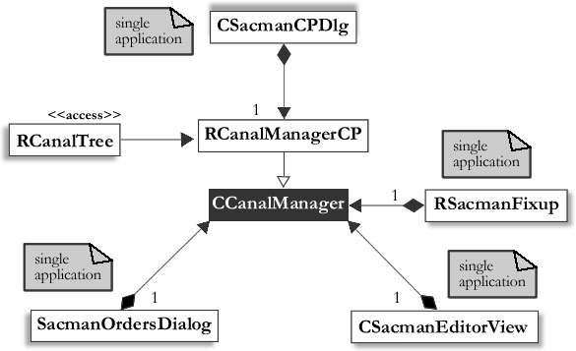

Figure UML diagram of the CCanalManager Object. A CCanalManager object contained a CSacmanEditorView object, an RSacmanFixup object, a SacmanOrdersDialog object, an RCanalManagerCP object and a CSacmanCPDlg object. Each class marked with “single application” was a dialog or separate program available to the user used to interact with the CCanalManager.

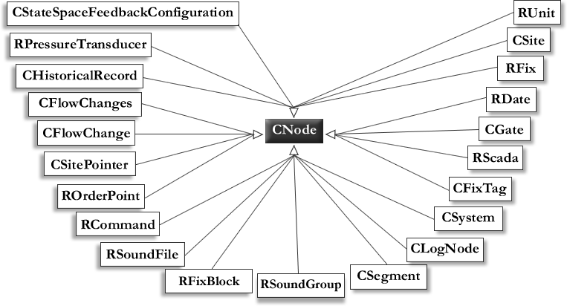

Figure UML diagram of the CNode class and all its derived classes.

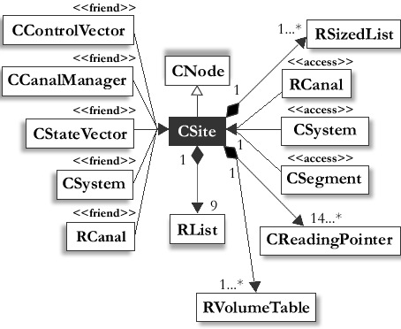

Figure UML diagram of the CSite class. The CSite class was composed of one or more RVolumeTable objects, one or more CReadingPointers and one or more RSizedLists. It is derived from CNode and had CControlVector, CCanalManager, CStateVector, CSystem and RCanal as friend classes. RCanal, CSystem and CSegment classes all had access to the CSite class via public functions.